Personal

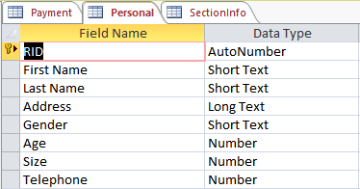

Payment

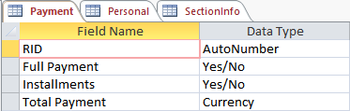

SectionInfo

